1. **Differential equations to represent a DC motor**

A canonical approximate model of a simple DC motor’s electrical and mechanical elements is shown in the diagram shown below in Fig. 1:

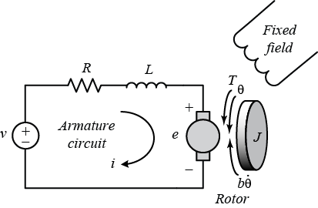

*Figure 1. Equivalent circuit schematic for a DC motor*

From first principles, derive differential equations that describe motor position in terms of the input voltage v and the motor’s mechanical and electrical dynamics. Use the following variable names in your derivation:

* v = Input voltage
* i = Armature current
* R = Armature resistance
* L = Armature inductance
* J = Moment of inertia for rotor
* e = Back E.M.F
* T = Motor torque
* θ = Motor position
* b = Motor viscous friction constant
* Kt = Motor torque constant
* Ke = Electromotive force constant

HINT: You may wish to proceed with this task as follows:

For the mechanical part of the system:

* Write down the expression for motor torque in terms of motor current.
* Write down the expression for torque that arises from the angular acceleration of the motor.
* Write down the expression for torque that arises from viscosity (in the motor bearings).
* Formulate an equation by equating the torque generated by the motor to that which arises from its intrinsic dynamics.

For the electromagnetic part of the system:

* Write down the expression for back EMF generated by the motor.
* Write down an expression for the voltage across the resistance in the circuit.
* Write down an expression for the voltage across the inductance in the circuit.
* Formulate a volrage equation by consideration to voltage balance.

1. **Differential equations in state space format**

* Write down the equations in state space format, which are of the form



* Write down the mathematical expressions for the state space matrices A, B, C, & D in terms of the motor variables.

1. **Numerically evaluate the state space matrices**

* To match the real motor, use Matlab to evaluate the matrices numerically using the following motor parameter values:
* R = Armature resistance 1 Ω
* L = Armature inductance 0.5 H
* J = Moment of inertia for rotor 0.01 kg.m2
* b = Motor viscous friction constant 0.1 NM’s
* Kt = Motor torque constant 0.01 N.m/A
* Key = Electromotive force constant 0.01 V/rad/sec

1. **Run a Matlab simulation**

* Use the Matlab ss function to build a Matlab state space model of the motor system using the state space matrices as input.
* Simulate the step response of the Matlab state space model using the Matlab step command.
* The step function will plot the step response onto a figure. Put on an appropriate title and label the axes appropriately.
* You should get something like the plot shown in Fig. 2 shown below:

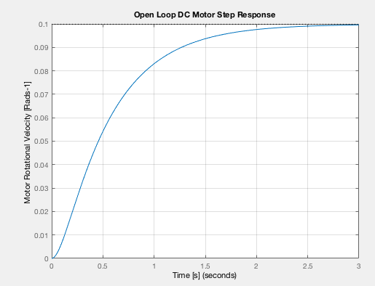

*Figure 2. Voltage step response of DC motor output velocity*

1. **Create a Simulink model to simulate motor velocity for a voltage step input**

* Use the Simulink state space block to realize the state space models of the motor system.
* Drive your simulation with a step function signal source.
* Add an oscilloscope signal sink and plot the output velocity of the motor and also the voltage input signal. Your Simulink models should look something like that shown in Fig. 3.
* You should get an output oscilloscope plot like that shown in Fig. 4 shown below:

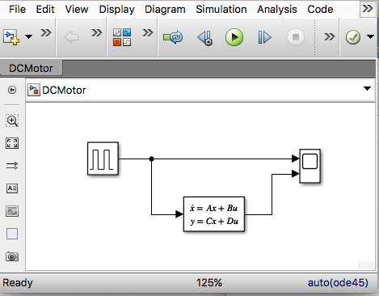

*Figure 3. Simulink model to simulate voltage step response of DC motor output velocity.*

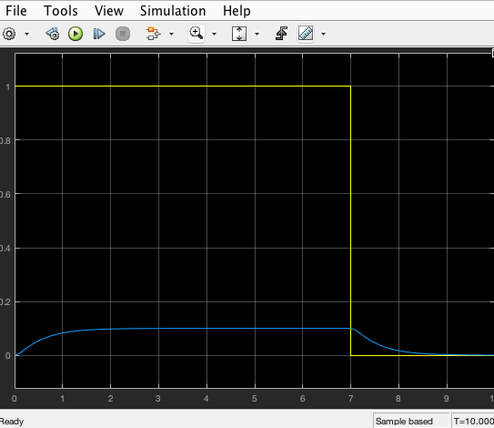

*Figure 4. Simulink simulation of voltage step response of DC motor output velocity. Yellow shows input step and blue shows velocity response.*

1. **Integrate motor velocity to simulate motor position for a given voltage input**

* Now add an integrator in your Simulink model to generate a position signal from the position signal and display this response together with the input step using another scope.
* Make sure you display the position response to a step input and the step input on the same scope.
* What can you say as a general comment about the response of the motor to an input step?

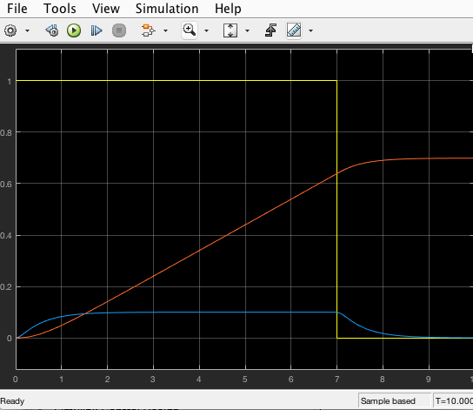

*Figure 5. Simulink simulation of voltage step response of DC motor output velocity and position. Yellow shows input voltage step, blue shows velocity response and red shows position response.*